Example #1: Use the figure at the right to complete Exercises 1–6.
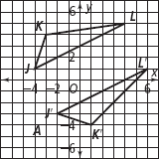
- What point is halfway between J and J′?

- What point is halfway between K and K′?

- What point is halfway between L and L′?

- What formula can you use in Exercises 1–3?

5. Use the points found in Exercises 1–3 to draw
the line of reflection. What is the equation of
the line of reflection? Use slope-intercept form.

6. Partner Share: Complete the steps above for your graph to find the line of reflection
Partner #1: Partner #2:
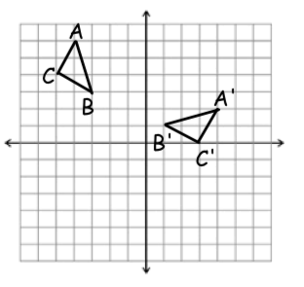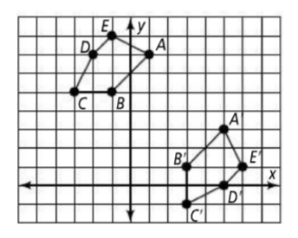

Homework: Draw the line of reflection on each grid with a straight edge. Then give the equation of the line of reflection in slope-intercept form.
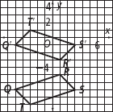
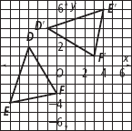
7.
8.

9.
10.
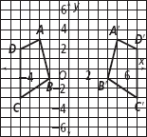
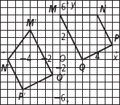

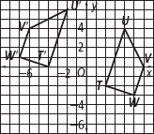
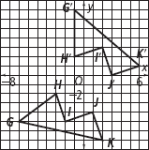
11.
12.

